+
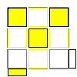 | 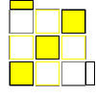 | 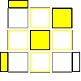 | 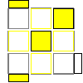
d R' U R U R' U2' R | U R U2 R' U2 R U R' U2 R U2 R' | U2 R U2 R' U R U2 R' U2 R U R' | U R U' R' U R U R' U' R U R'
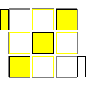 | 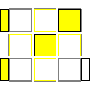 | 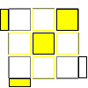 | 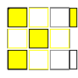
(U') R U2' R' U R U R' | L2 D' L' U L D L2 U L U2 L | U R' D' R U R' U' R U' R' U2 D R | U2 R U2 R' U2 R U R' U' R U R' or U' R U R' U' R U' R' U' R U R'
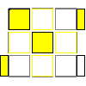 | 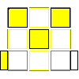 | 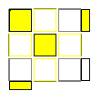 | 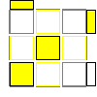
(U) R U R' U2 R U R' | R' D R' U2 R D' R' U2 R2  or U2 R2 U' L' U R2 U' L | R U' R' U2 R U' R U2 R2 U' R2 U' R2 | d R' U R U2 R' U R
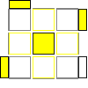 | 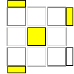 | 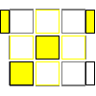 | 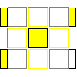
U2 R U R2 U' R U' R' U2 R2 U2 R' | U R U R' U2 R L' U R' U' L or U R U R' U2 R U2 R' U R U2 R' | R' U R U2 R2 U' R U2 R' U' R2 | R U R' U R U' R2 U2 R2 U R2 U R
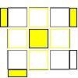 | 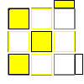 | 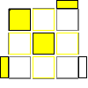 | 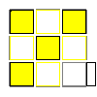
U' R U R' U2 R U' R' U2 R U R' U' R U R' | (U) R U L U' R' U L'  or U R U2 R' U2 R U R' U R U' R' | U2 R U' R' U R U' R' U' R U R' U' | L D' L' U L D L'
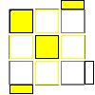 | 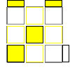 | 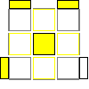 | 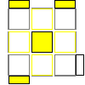
(U2') R' U' D' R U' R' U2 D R or U R U' R' U R U R' U' R U' R' U' R U' R' | (U') R2 U2 R' U' R U' R2' U R U R' | (U') R U2 R' U R U' R' U' R U' R'  or R' U2 R U2 R U' R' U' R' U R2 U R  or U R U R' U R U' R' U' R U' R' U' R U R' (j`eynub found this) | (U') R U2' R' U R U' R' U' R U' R'
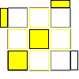 | 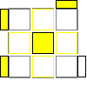 | 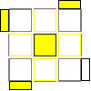
U2 R U' R' U2 R U R' U R U R' | Y' U' R' U' R U' R' U' R U R' U2 R or U2 R U' R2 U2 R U R' U R U2 R U' R' | U' R U2 R2 U2 R U R' U R2 U' R'  or R U R' U2 R' U' R2 U' R2 U2 R2 U R'  or U' R U2 R2 U2 R U R' U R2 U' R'
-
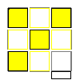 | 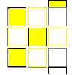 | 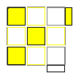 | 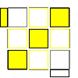
L' D2 L U2 L' D2 L | U R U2 R' U' R U R' U R U2 R' U R U2 R' | (U') R U' R' U' R U2 R' | x U' L U R U' L' U R x'  or U' R2 U2 R' U' R U' R' U R' U' R U2 R'
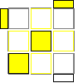 | 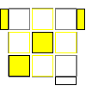 | 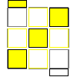 | 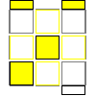
U2 R U R' U R U R' U' R U' R' U2 R U R' | R U2 R' U R2 U2 R' U' R U' R2 | d R' U2 R U' R' U' R  or R U R' U' R U' R' U2 R U2 R' | U' R' U' R' U' R' U R U R2 U2 R' (OH)  U2 R U' R U2 R' U' R' U R2 U2 R2 (2H)
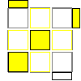 | 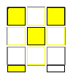 | 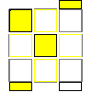 | 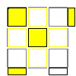
R U' R2 U2 R U R' U R2 U R' | R U R' U' R U' R' U R U' R' | R U' R U2  R' U' R U' R2 | R' U R U' R U' R' U2 R U' R2' U' R
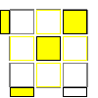 | 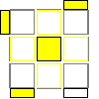 | 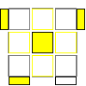 | 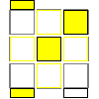
(U') R U' R' U2' R U' R' | (U) R U2 R' U'  R U R' U R U R' | (U2) R U' R' U2  (R U2 R' U2 R U' R') | R U' R U2' R' U' R U' R2
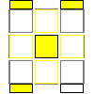 | 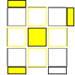 | 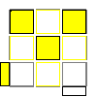 | 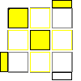
R U' R' U R' U'  R U' R' U2 R2 U' R' | U2 R U R' U2 R' U' R U' R' U2 R2 U R'  or U' R U2 R U2 R' U' R U' R2 U' R U2 R' | (U) L U' R U L' U' R' | R 'F R U2 L F L' U2 F'
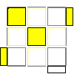 | 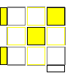 | 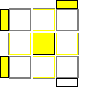 | 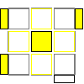
R2 U R' U R2 U' R2 U R' U2 R2 | (U') R' U R2 U R' U2 R U R' U R' U' R | U R2 U R' U R U2 R' U R'  or U' R U' R' U R' U2 R U R' U R2 U2 R' | U' R U' R' U2 R2 D R' U' R D' R2 or R2 U2 R U' R' U R2 U' R U' R' U R'
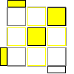 | 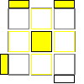 | 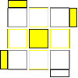
U' R U' R' U2  (R U R' U') (R U' R')  or  U2 F' anti-sune F | (U) R U R' U R U R' U' R U2 R' | U' R U' R' U'  (R U' R' U) (R U2 R')
O (108/405)

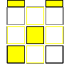 | 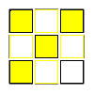 | 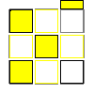 | 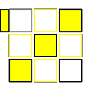
(R U R' U')*3 | U2 R2 U2' R2' U' R2 U' R2' | U2 R U2 R U2 R2 U' R2 U' R' U R'  or U2 R U2 R' U2 R U' R' U2 R U2 R' | U2 R U' R' U R U R' U R U' R'
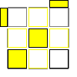 | 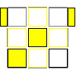 | 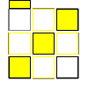 | 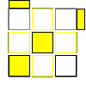
R U' R2 U' R U'  R' U2 R2 U R' | U R U R' U' R  U2 R' U R U' R' | U R U R' U R U' R' U R U' R' U2 R U R' | U2 R U' R' U' R U'  R' U2 R U R'
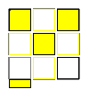 | 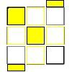 | 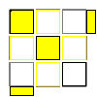 | 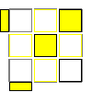
U (R U2 R' U')*3 | U' R U R' U R U'  R' U2 R U R' | U R' U R U' R2 U'  R2' U2 R2 U' R U' R | F' Sune F
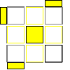 | 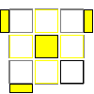 | 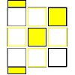 | 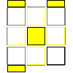
U2 R U2' R' U2 (RU' R' U) *2  or  U' R U' R' U R U' R' U R U R' U R U R' | R U2 R' U' R U' R' U R U' R' U' R U2 R' | U' R U2 R' U2 R U2 R' U R U' R' | U2 R U' R' U R U R' U R U R' U' R U' R'
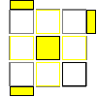 | 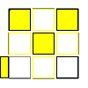 | 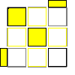 | 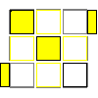
U R U R' U R U' R' U' R U R' U R U' R'  or U R U' R' U R U' R' U R U R' U' R U' R' | U' R U R' U' R U R' U R U' R' | U R U R' U' R U2 R' U2 R U2 R' | U2 R' U R' U' R U R' U R U2 R' U2 R U' R  or U' R U2 R' U2 R U2 R' U2 R U' R' U R U2 R'
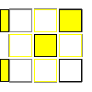 | 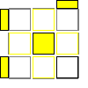 | 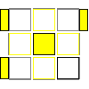 | 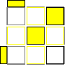
y' (R' U' R U)*3  or R U R' U' R U R' U' R U2 R' U R U2 R' | (U) R U2' R' U' R U2' R' U2 R U' R' | R U R' U2' R U2 R' U2' R U R' | R U2 R' U' R U' R' U R U' R' U2 R U' R'  or R U R' U R U R' U R U' R' U' R U R'
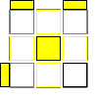 | 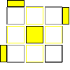 | 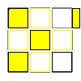
U2 R' U2 R U R' U2 R U2' R' U R  or R U R' U R U2 R' U' R U R' U2 R U R' | (U') R U R' U' R U R' U2 R U2' R' | U' y' (R' U2 R U) *3  or R U R' U R U2 R' U R U2 R' U R U R'
I

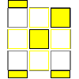 | 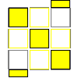 | 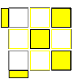 | 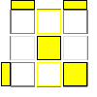
R U R' U' R  U2 R' U' R U R' | R U2 R' U2 R  U2 R' U' R U R' | U2 R U' R' U' R  U R' U2 R U' R' | U' R U' R' U' R  U R' U' R U2 R'
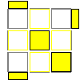 | 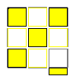 | 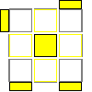 | 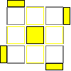
(y') R' U2 R U' R' U R U' R' U' R  or  U R U' R' U' R U R' U2 R U R' U' R U' R'  or  or R U R' U2 R U' R' U2 R U2 R' U2 R U2 R' | x R U2 R' U' R U' R' L' U2 L U L 'U L x'  or  R U2 R U R' U R U2 R' U2 R' U' R U' R'  or  U' R U2 R' U R U2 R' U' R U' R' U' R U R' | R U' R' U2 R U' R' U2 R U' R' U2 R U' R'  or  R U2 R' U' R U' R U2 R' U' R U' R' U2 R'  or  U R U2 R' U' R U R' U2 R U2 R' U' R U R' | (R U2 R' U2 R U R' U')*2  or  R U' R' U' R U R U' R' U R' U R' U R' U' R
.
Im

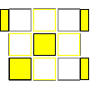 | 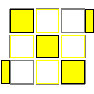 | 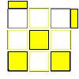 | 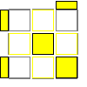
R U' R' U R U2 R' U R U' R' | R U' R' U R U2 R' U2 R U2 R' | U R U R' U2 R U' R' U R U R'  or  U R U2 R U R' U R U2 R2 | U R U R' U R2 U R' U R U2 R2  or  R U' R' U2 R U R' U' R U2 R' U2 R U' R'  or  U' R U R' U2 R U' R' U R U2 R' U R U2 R'
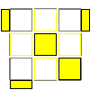 | 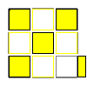 | 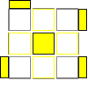 | 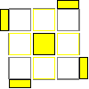
R U2 R' U R U' R' U R U R' | U2 R U' R' U R U2 R' L' U R U' L R'  or R' U' R' U R U' R U' R U' R U R2 U' R  this case sucks. | R U2 R' U R U' R' U R U' R' U' R U' R' | R U' R' U2 R U2 R' U R U' R' U2 R U2 R'  or  U' R U' R' U2 R U2 R' U R U' R' U2 R U2 R'

Algs found from various sources:
-Lucas Garron (Images credited to this guy, too.)
-Shotaro Makisumi
-Sarah Strong

and then I decided that I despise rotations, and hate L moves, and subsequently went through every single case trying to get the best alg for each one.

Ooh. Green is pretty. :e

-statue

